DETERMINING THE AGE OF AN OLD BARN
By Mark Pilipski

BARNS are NOBLE
box 588

westbrookville, ny 12785

There is a sense that barns represent a more pastoral time than today. Barns harken back to a time and life that evokes memories of children jumping into piles of hay and waiting out a storm in the loft before they returned to climbing trees and skinny-dipping in the pond. Light entering a large dark barn is suffused into a romantic notion, a blending of the working masculine and the productive feminine. We all love the idea of barns.
There are several simple steps and observations that will allow you to accurately estimate the age of an old barn or similar building.

Check the records:

The property contains three
buildings; a house, a barn
and a carriage house, each
of these is situated near the
road.

Usually, a title search is done to assure that the buyer has clear title to the land. You don’t want to buy your dream home only to find that some second cousin of the presumed owner, away traveling the world, is the real owner of the land. Most title searches begin with the registrar of deeds, usually found in town halls, the county seat offices, or the State Capitols. Land deeds are registered and these records are kept, in most cases, from the earliest colonial land grants to the present. To find the personal history of a barn, begin by finding the deed for the property that contains the barn within the records. This process is very much like finding a book in a library. Most town clerks and registrars of deeds are happy to explain how it is done within their offices. Often you may find mention of a barn in a deed. That gives you an approximate starting point. You know that the barn was built sometime before it was mentioned in a deed.

Since barn raisings were usually community events, some mention of them may be found in the newspapers of the time. This source, of course, is only found in larger communities. Most early settlements had no printers or news flyers of any sort.

Examine the barn:
Often (and especially with old buildings) you’ll find that someone has carved his or her name or initials into a piece of timber. Sometimes a date is included. This date graffiti may not be the date the barn was built but it certainly was carved into the timber after the barn was raised.

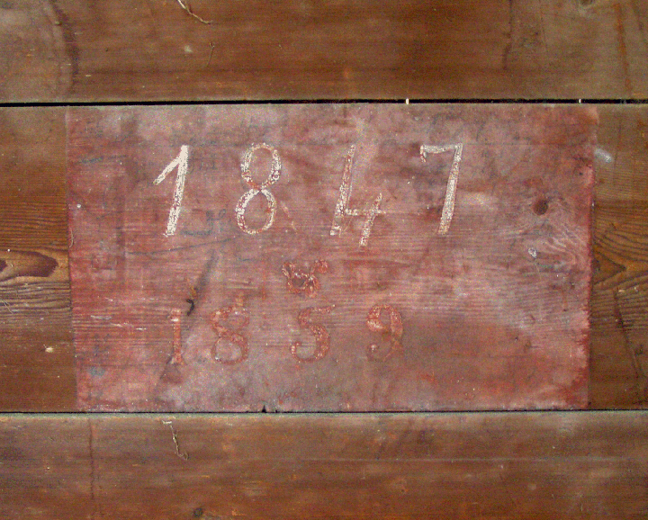
Dates, 1847 & 1859, on a board inside of a barn

Barns were built for their utility. They were not designed to be fanciful emblems of one’s wealth. They were designed to hold hay, farm equipment and to shelter animals. They contained just those elements required for survival. Years later they became buildings of distinction. Sometimes the builders would note the date on the barn itself. More often than not someone a few generations later would carve a supposed date in a beam or post.

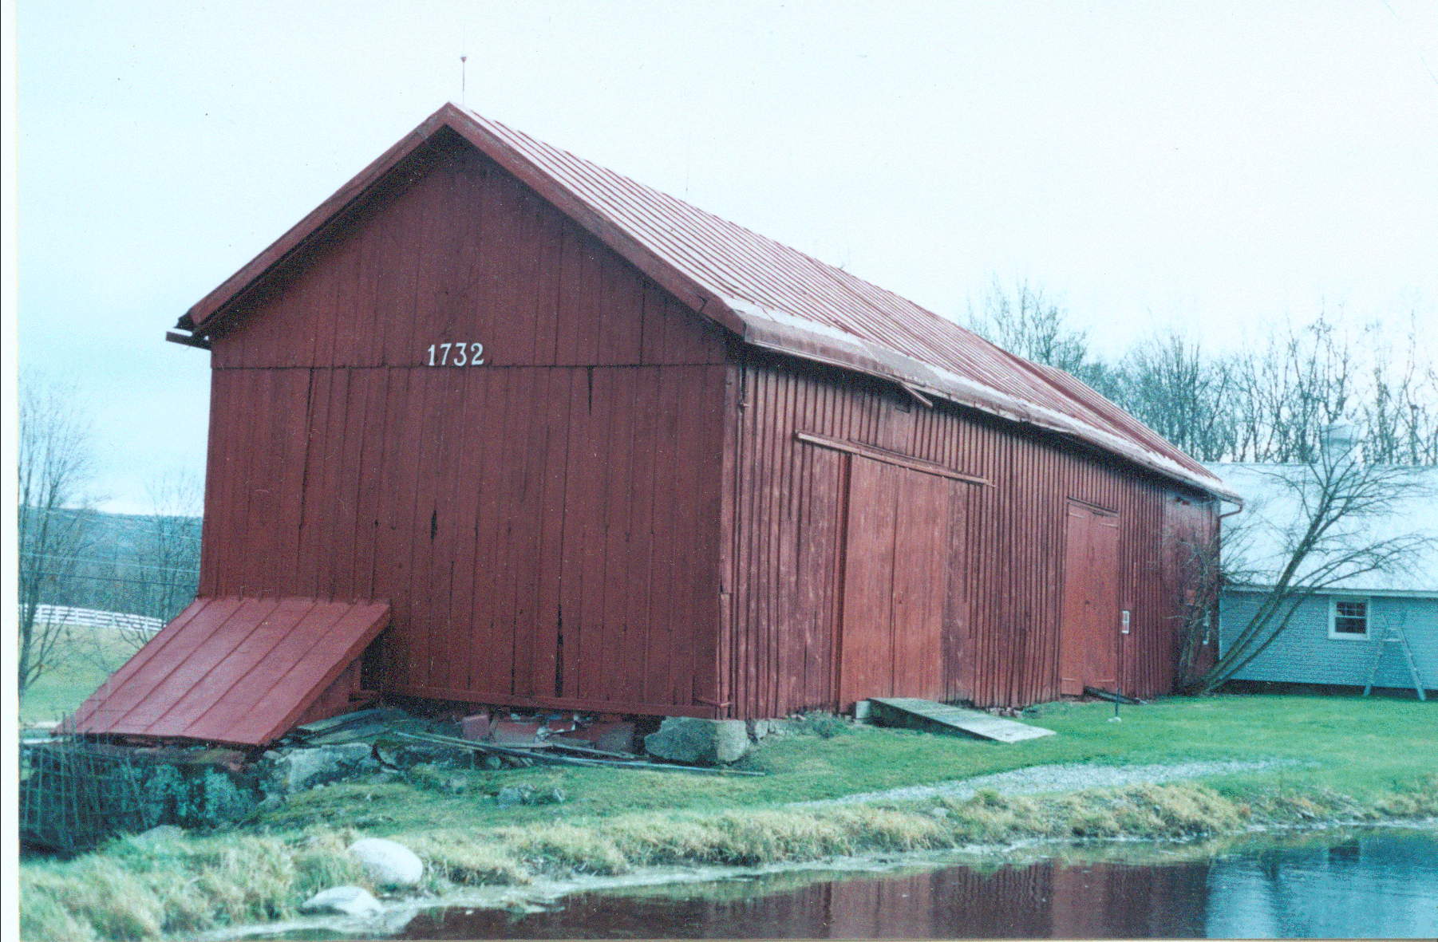
Date on the side of an English barn

With knowledge of the date and the initials of the carver, you may be able to correlate these with an old deed to find the owner who dated the barn. Such graffiti may not be the work of the builder or owner rather that of a neighbor’s child, playing in the barn or waiting out a rain shower. In this case your date may not find any confirmation in the official records.

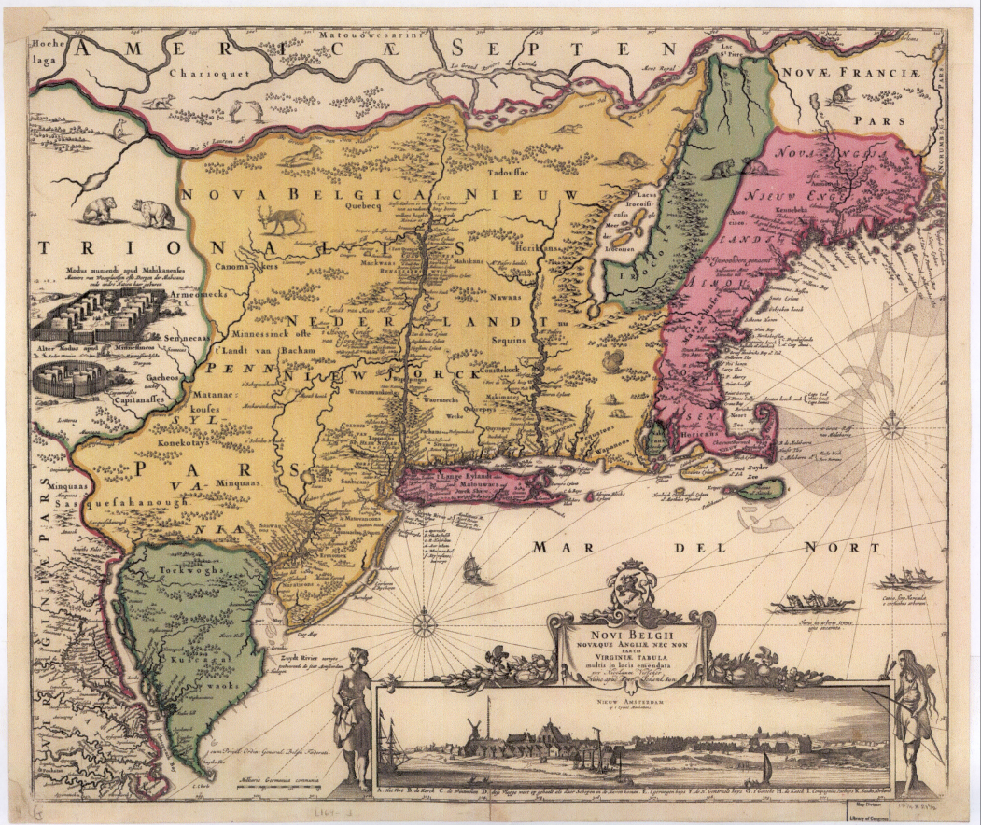
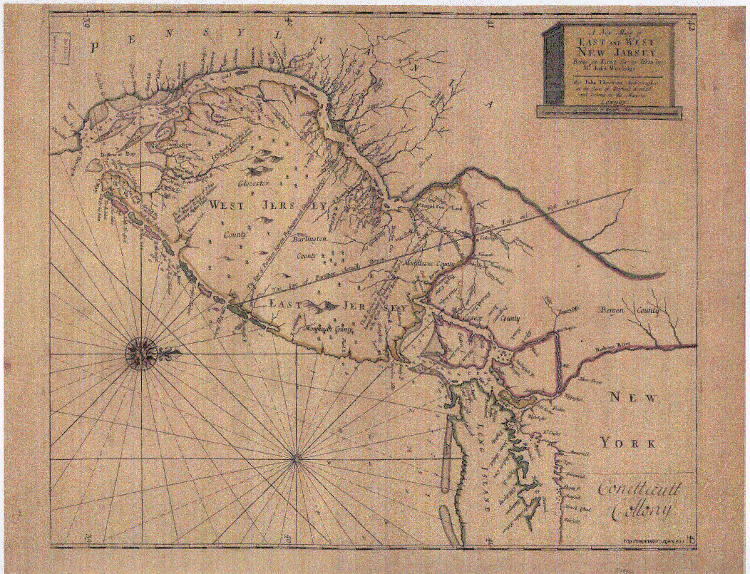

Early maps of New England and New Jersey

Geographic location gives us some hint of the barn’s age. For example, a Dutch type barn built in Southeastern New York State or Northern New Jersey with hand-hewn timbers may be dated to about 1780; a period when Europeans settled into these regions.

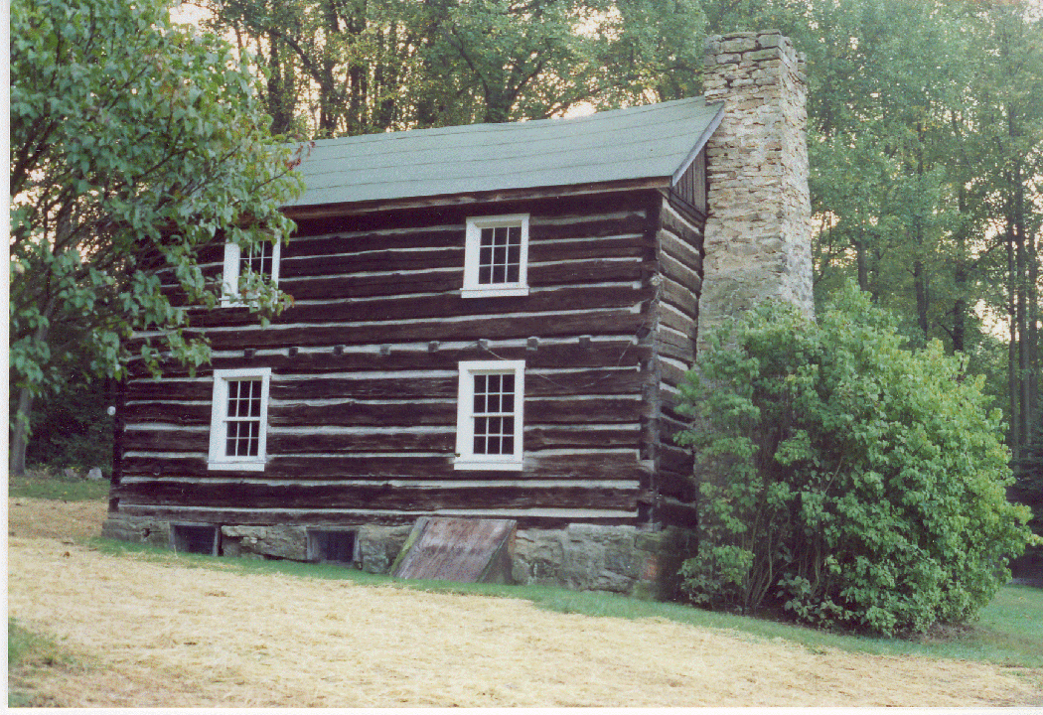 | 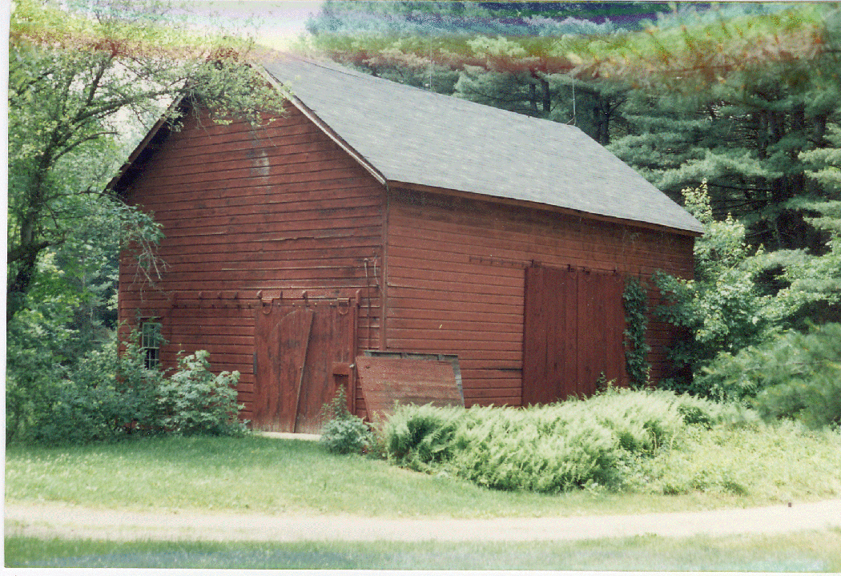
A log cabin in Western PA, circa 1860 | Barn in Southeast NY, circa 1780

A similar structure or even a more rustic log cabin located in Western Pennsylvania may be dated only to 1860 (around the time of the Civil War) because that’s when the wave of settlement came to that area of the country. A local historic society should be able to give you some insight into the flow of immigrants and development around the locale of the barn.

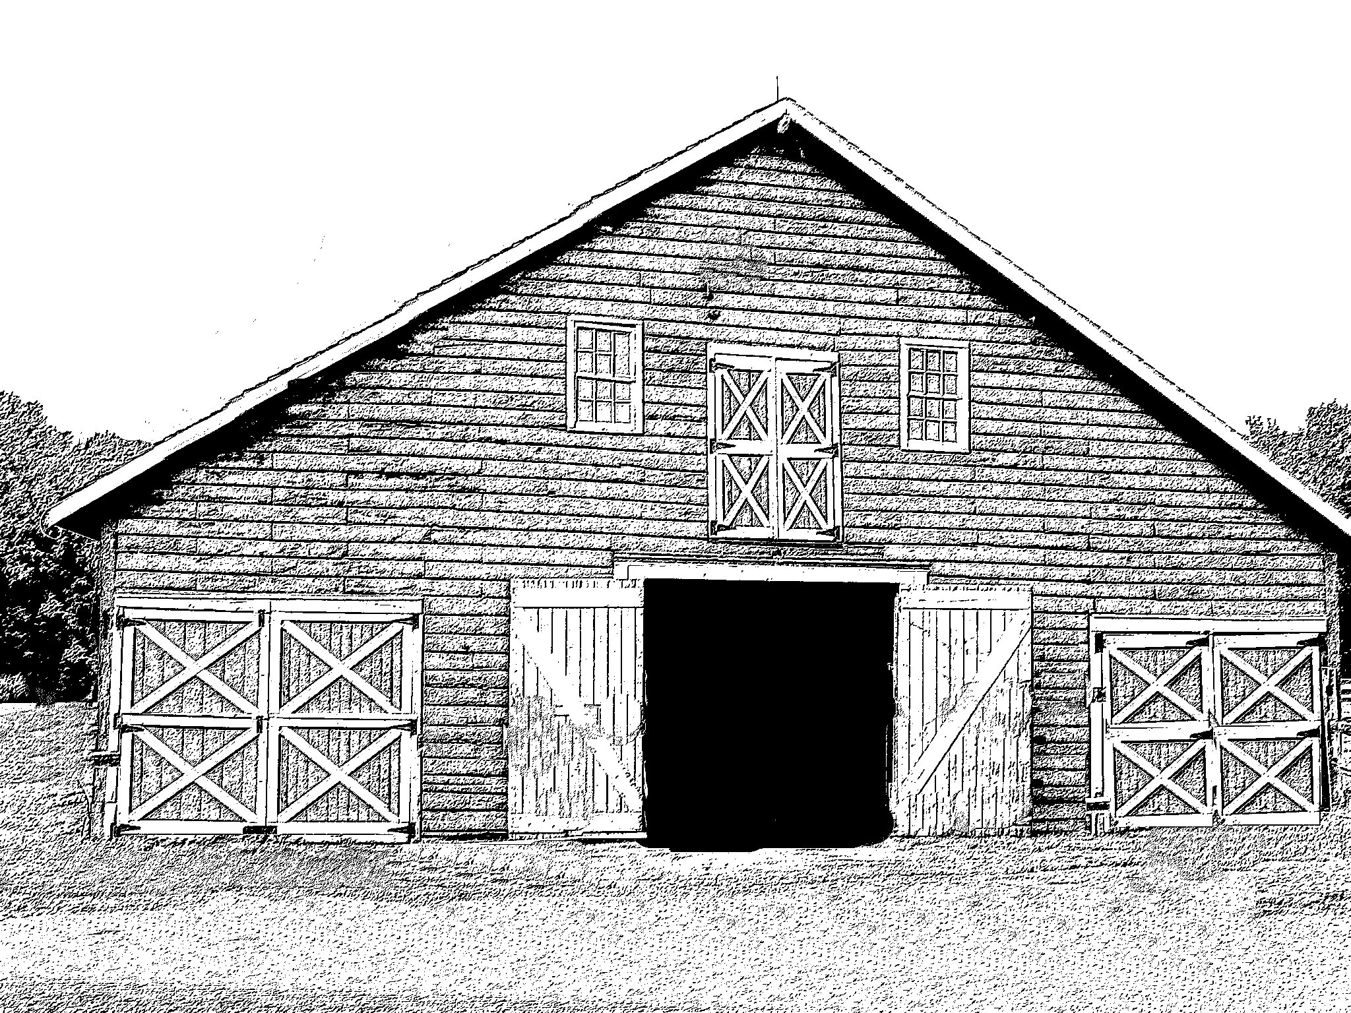 | 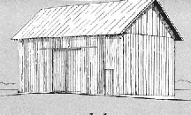
Dutch Barn English Barn

The type of construction also provides a clue as to the date of the barn’s origin. However, it is common, now and then, to have a single carpenter or mason direct the construction of a barn. The style of construction will be what this individual knows well. If he learned how to construct a Dutch barn on a bank of a gravel hill that is the type of barn he will build for the owners. There are no hard and fast rules relating construction styles and the age of a barn. You can find a circular barn amid several stone barns or a Dutch barn far away from any Dutch settlements. A good rule of thumb, however, is if your barn is similar to several other surrounding barns and you have a date for one or two of those; your barn was probably constructed in the same period.

List of types and dates and locales:

Dutch | 1640s  1840s | square | Doors on gable end | Large beams  Three bays
English | 1780s  1850s | rectangular | Doors on long side | Most common barn in NE
Bank (Basement) | 1850s  1920s | rectangular | Doors on two levels cupola at roof crest | Hay loaded into the upper level, cow stalls in the lowest level
Circular (Round) | 1850s  1880s | round | Ramps between levels | Hay storage  in the center
Tobacco |  | tall | Drying ‘wings’
Stone | any | any | any
Gambrel-Roof | 1800  1920s | rectangular | double-pitched roof | ‘Classic’ barn

The lumber used in the construction of an old barn also points to the date of construction. The native hardwoods, oak and chestnut were harvested first to build barns. Later dates find softer woods such as hemlock used for posts and beams.
The presence of hand-hewn beams tells us that an axe or adze was the only cutting tool available to the barn builders. These were the tools of the pioneers, the first settlers in a region.

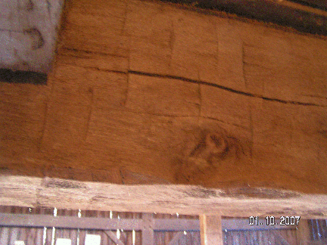 | 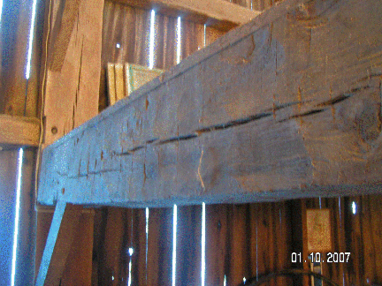
Hand-hewn beams

Sawed lumber appears to be used later. Period saws were bulky devices requiring two men to use them to form a timber. Such saws left rough-cut saw marks on the timbers and also left slightly wavy surfaces.

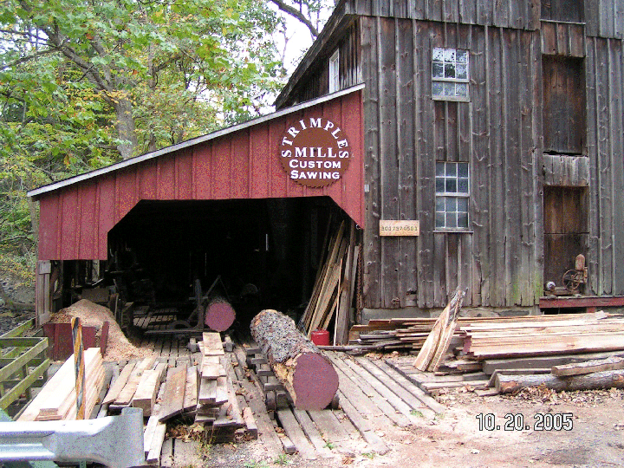
Sawmill

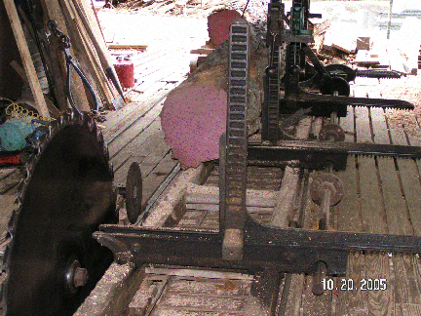 | 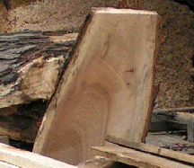
Circular saw blade | Board showing arced cuts

The next technology applied to barn building was the use of a sawmill. Some very early mills used straight saw blades. Straight saw blades leave straight saw marks on the boards they produce. More effective sawmills used circular saw blades. These, too, left rough-cut saw marks on the timbers but these cuts have a slight arc owing to the radius of the large circular saw blades. The faces of the milled timber beams and posts are flat.

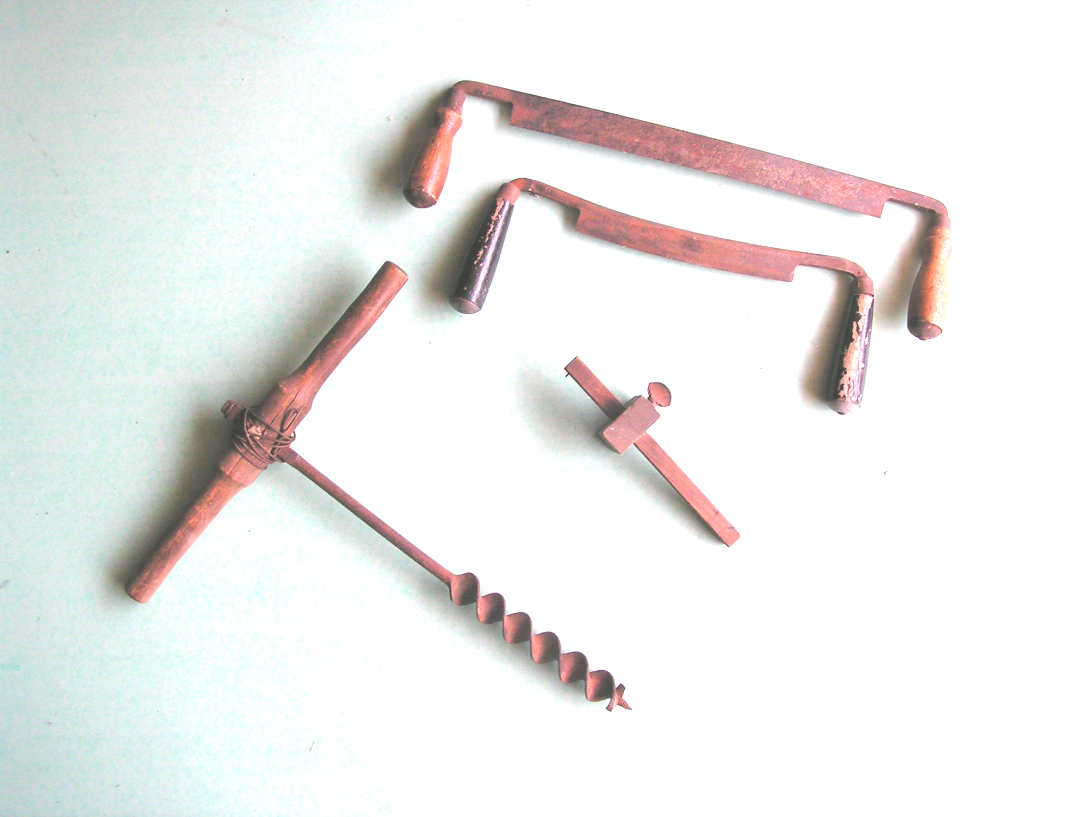
Tools for barn building

Once the steam powered lumber mill was developed, we see timbers cut with smoother surfaces because the speed of the steam driven blades increased over the water wheel driven mills.
Contemporary dimensioned lumber is milled and finished before it leaves the mill.
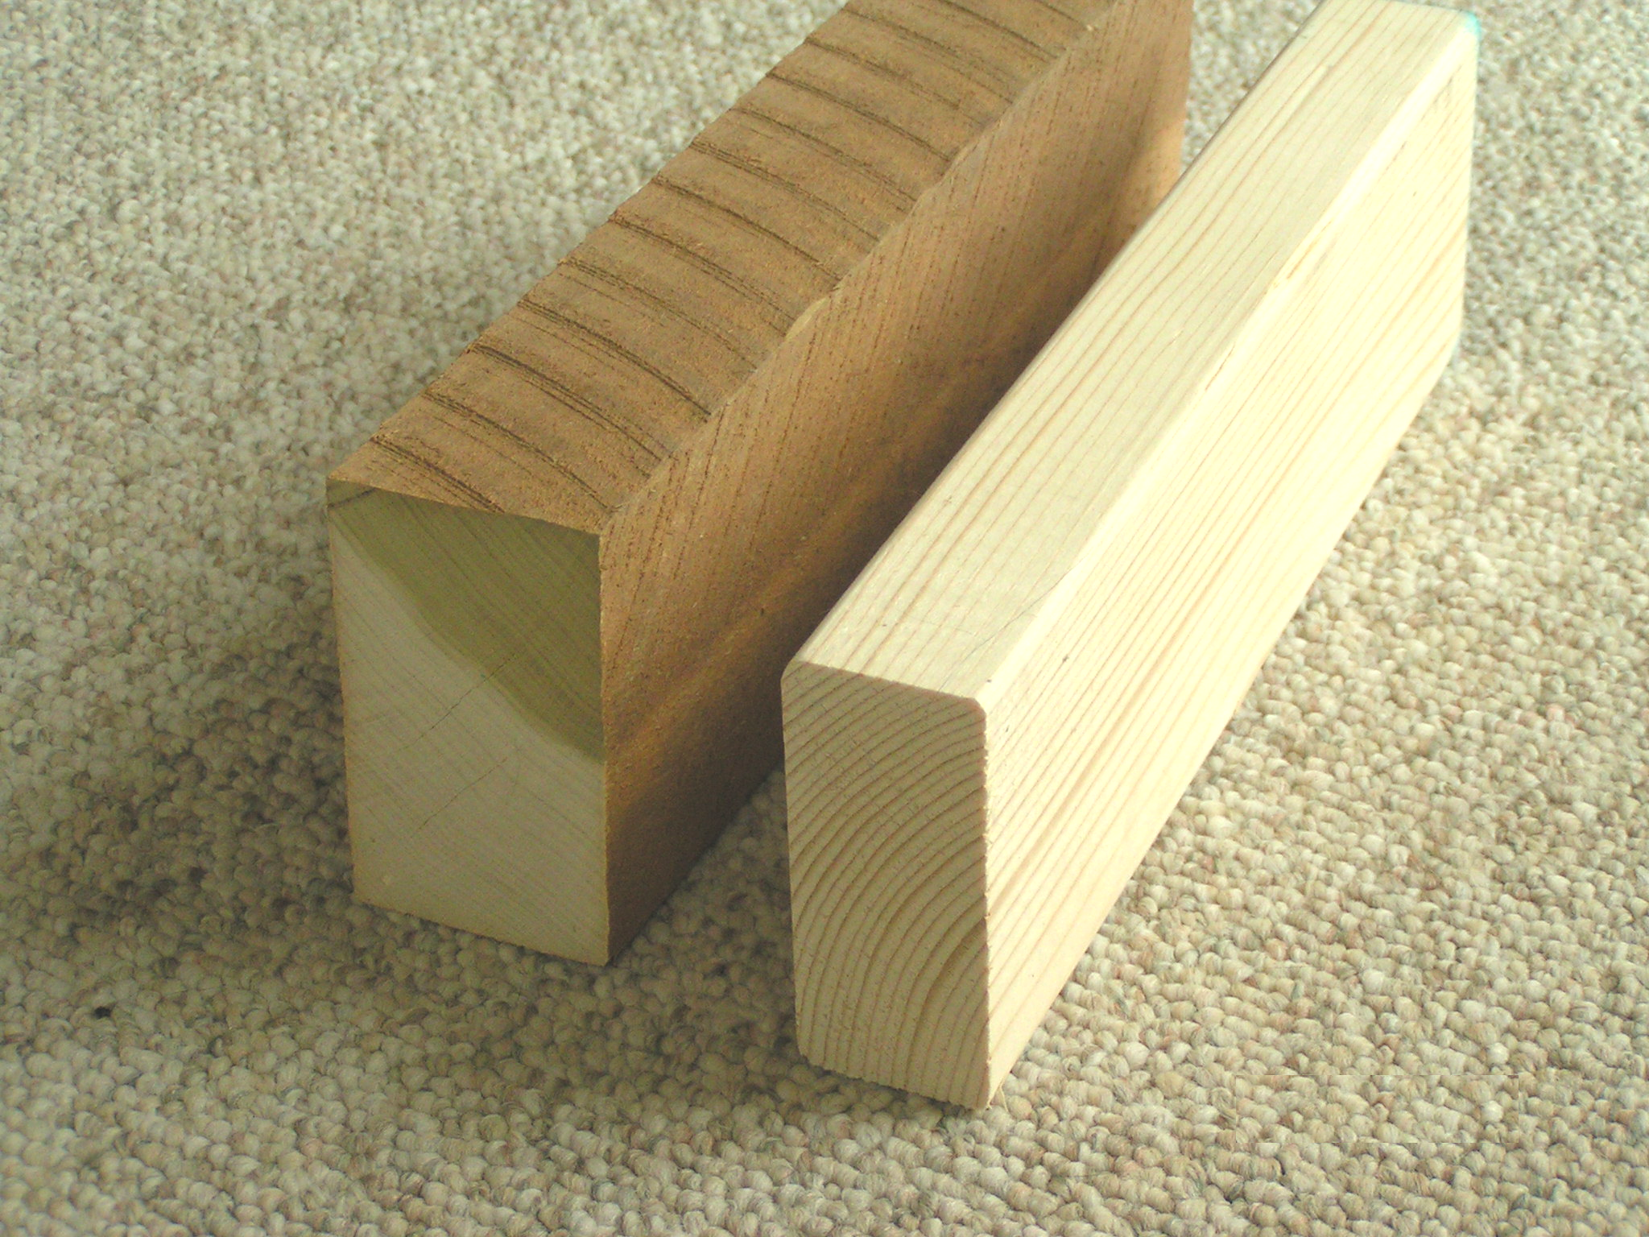
“Rough cut”(older) and “Dimensioned” (modern) 2x4s

How does this information help us date a barn? Well, if you find milled timbers in the barn and the only local sawmill was built in 1850, then your barn was built sometime after 1850. Or, at least, we know that some of the milled timbers seen in the barn were milled after 1850. Further, dimensioned lumber cut before the Second World War was usually sized in inches. A 2 x 4 was 2 inches by 4 inches. Sometime after WWII, dimensioned lumber became standardized at smaller measures to accommodate modern building materials such as plywood and sheet rock.
Design and layout of a barn give us broad hints as to its age. The details of the construction are also helpful at determining the date the barn was constructed. Individual timber joiners having previously learned the craft of barn building, designed the earliest barns. These men were often itinerant workers who were paid well. Their job was to direct every facet of the barn’s construction. They would specify the number of posts and beams and the dimension of these timbers. Others would harvest the trees and trim the logs to the barn-builder’s satisfaction. The craftsman would then cut and sculpt the appropriate mortise and tenon joints onto the ends of these timbers. Once all the pieces were crafted the barn was assembled (raised) by a crew of laborers. To make the assembly easier, the timber framer cut ‘carpenter marks,’ usually in the form of Roman numerals, into the mating pieces of timber, to guide the laborers and to prevent the misassemble of the pieces. The presence of ‘carpenter marks’ on beams or struts is a good indication that the development of that particular barn was the work of one craftsman.
Similar handiwork may be seen in the masonry used for bank barns. Although the indications of such are far more subtle than ‘carpenter marks.’ Foundations for early barns were constructed of stones. For barns built upon level ground without any basement area, we see simple stonewalls or footings placed to raise the bottom timbers (sills) just above the winter’s snow line. Often a hired stonemason would begin the process of building the foundation walls for a barn. Gathering, cutting and laying stones is a labor-intensive activity; several locals, usually, worked along with the stonemason. While he worked, the locals, the farmer or his sons would help the stonemason and learn the craft and technique of cutting and laying stone. Occasionally, the cost of keeping the services of the stonemason became prohibitive. Once the craft was learned, the stonemason would move on to his next job and the farmer or local laborer would complete the foundation. Evidence of this is seen by comparing the base of a foundation with the top courses of the same foundation. Often, you will find clean cut rectangular stones set near the ground in level courses. These yield to somewhat irregular shaped stones set in meandering layers, as we approach the top. This is a clear indication of the work of two or more men. In a foundation built by one or two stonemasons, working together, we see a consistency in the composition and construction of the entire foundation. The bottom and top courses of the foundation are clean cut and are formed by level lines of stones. In a foundation started by a stonemason and completed by his helpers, we see clean bottom courses of stone and a tendency toward ‘sloppiness’ as the courses approach the top of the foundation. In many barn foundations, the stones are not as neatly cut, the courses are not quite level and the gaps between stones tend to be larger than on the bottom courses.

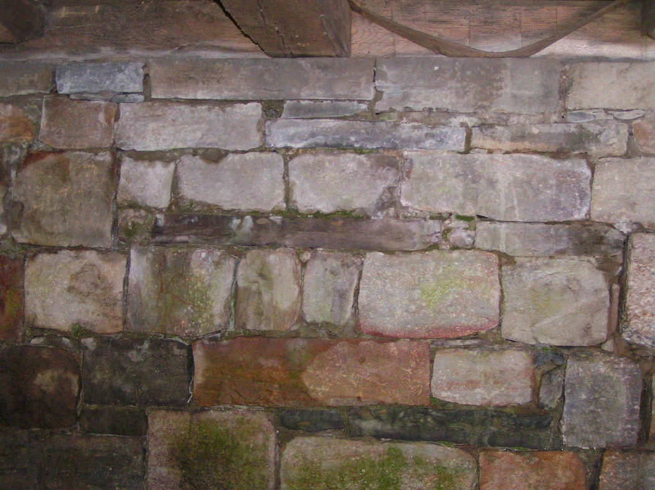 | 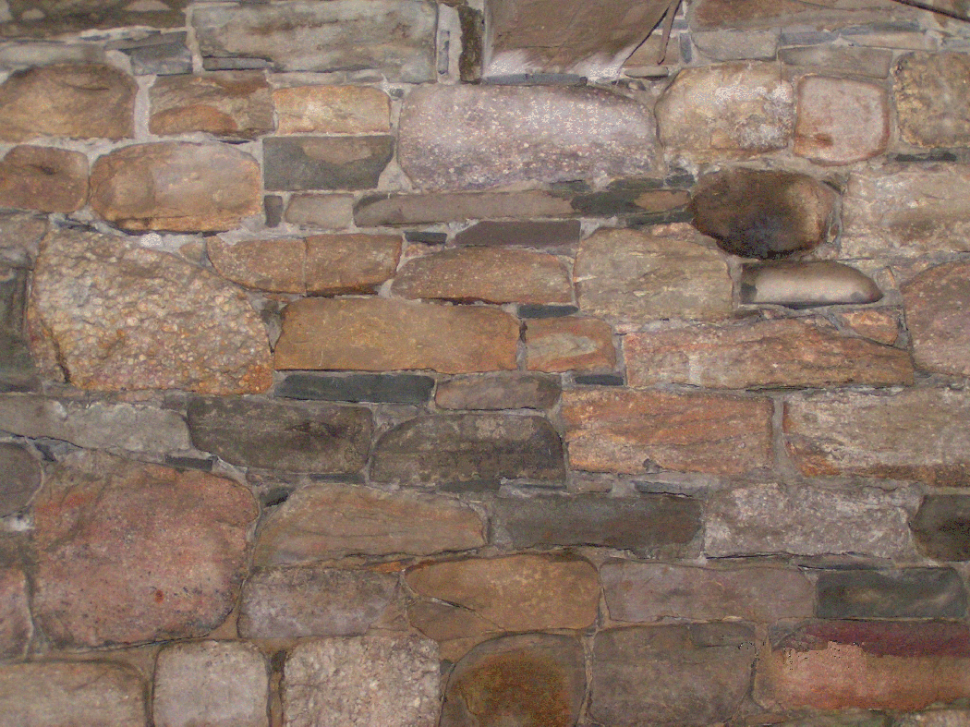
Foundation with level courses | Foundation with uneven courses

The use of any type of mortar also gives some indication of the date(s) the foundation was constructed. Mortar is used as a filler between stones. It is never to be used as a ‘glue’ to bind stones together. The earliest form of filler was probably native clay. Moist clay packed over straw or animal fibers (i.e. horsehair) provided a good filler to close gaps in a foundation or wall. Clay, unless it is fired, however, does not resist water. A mortar made with lime (dehydrated limestone) does, to a certain extent, resist water. A simple lime mortar required a limekiln in the neighborhood. The existence of a nearby kiln may be documented and, hence, fix a date of construction. However, most barn foundations, as is true with almost all early foundations, are made with laid dry stones. The presence of mortar within the foundation is more probably due to someone’s efforts to ‘patch’ the foundation at a later date.

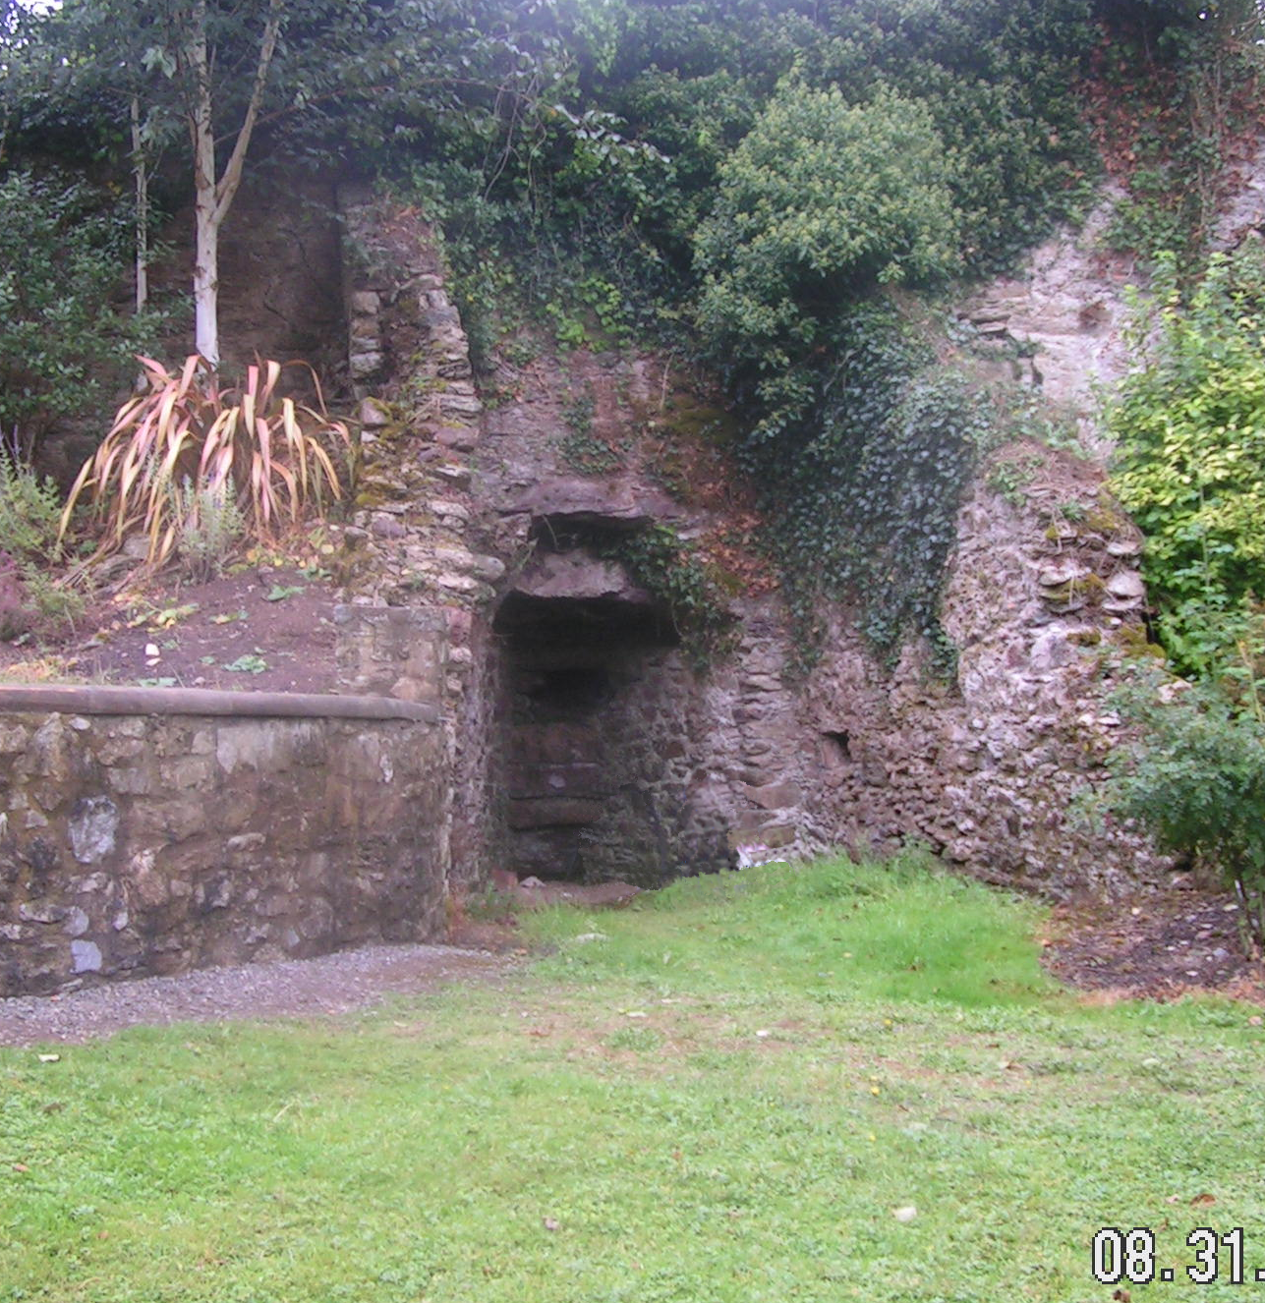 | 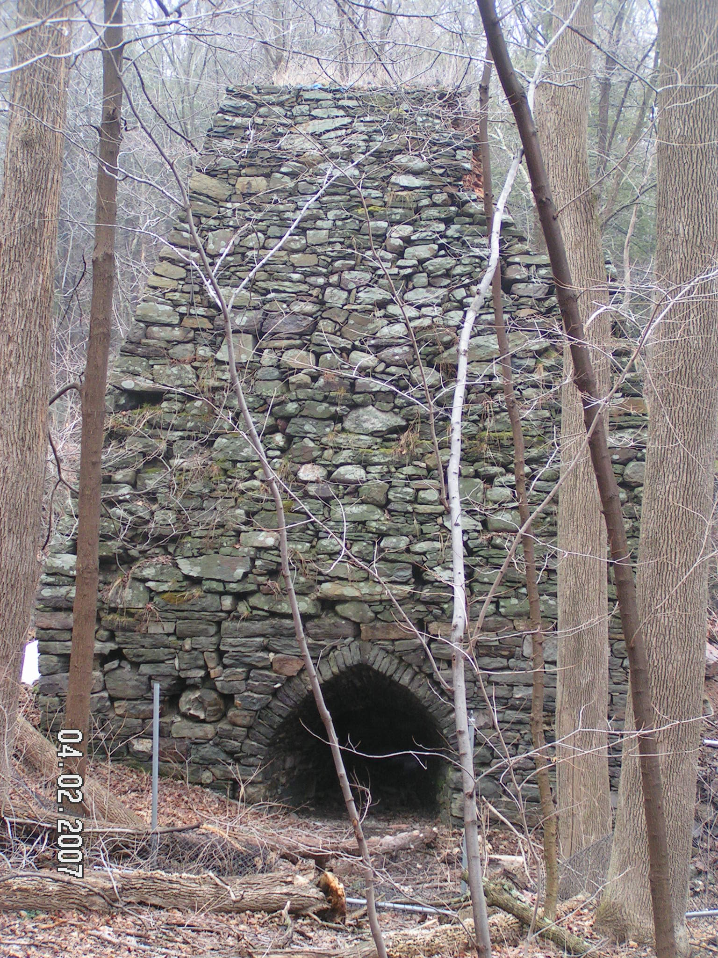
Lime Kiln | Iron Furnace

Salvage:
Most barns, of any type, have not survived exactly as they were built. Often barns are a composite of the materials from several distinct buildings. Two small barns might have been combined into one larger barn. Beams from a disused barn may be put to good use in a new barn. Siding and roofing may have been changed many times in an old building. Therefore, finding and dating a timber within a barn may not lead you to accurately dating the entire barn yet this information is helpful. The timbers salvaged from earlier barns used within newer barns probably belong to the same line of owners, separated by a generation or two. Thus you can reasonable adjust your estimate of the barn’s age, knowing something about the age of the timbers used for construction.

 | 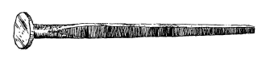
Hand-wrought | Type-A (~1740~1785)
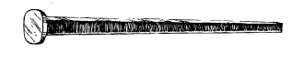 | 
Type-B (~1805~1852) | Wire (1855-Present)

Humble iron nails, used to attach siding to a barn frame may also tell you something about the age of a barn. The history of nails traces the history of the industrial revolution. Colonial nails were handmade and imported. These nails were hand-made (forged) and used well into the 1800s. They appear to be small and various sized spikes forged by a blacksmith from an iron rod. The rod was tapered and then the small end of the taper was cut from the rod to form a nail. Once a smelting furnace or kiln was built in the area, native iron could by extracted and worked. Flat sheets or strips of iron would be cut into long triangular nails. These most resemble the modern ‘horse shoe’ nails. They had no ‘heads’. The cut nail made its appearance in the mid-1700's but was not produced in sufficient quantities until 1785. Cut nails could be manufactured much faster than hand-forged nails. These are called ‘A’-type cut nails. During these years, Thomas Jefferson established a nail factory at Monticello to supplement farm income. Jefferson’s nail factory made both hand-forged and cut nails. The next generation of nails was developed from these cut nails. A blacksmith would place a nail into a form and ‘pound’ or flatten a head onto the widest end of the nail. This minor modification made the nail useful for holding siding to the frame of a building. A nail-making machine was patented in 1805 and production ‘B’-type cut nails started about 1852. It would not be until the middle-1800's that cut nails became prevalent in the marketplace. Cut nails are not actually "cut"--they are sheared from an iron or steel plate that is as thick as a nail shank. Although often called "square nails", there is a slight tape along the shank of the nail, owing to the cutting angle of the machine shear. Thus, hand-forged nails have all sides tapered. Cut nails have two sides parallel and two sides tapered. Cut nails were popular from about 1820 (development of the Type B nail) to 1910, the invention of the wire nail in 1855 supplanted the cut nail. The next development in the making of nails was the production of wire. Iron was pulled through a die to produce wires and rods of various diameters. These wires were then cut to form nails. Water or steam power was required for this type of nail production. These wire nails evolved into our modern nails.
Using the above information nails can be dated as follows: Hand-wrought nail, before circa 1800. Type A cut nail, circa 1790-1830; A cut nail that has opposite side (face and back) cutting burrs, is side pinched, and has a grain that runs across the shaft dates 1790-1848. Type B cut nail, circa 1820-1900. A nail that has cutting burrs on the same side, is crossed grained, and side pinched dates 1835-1848. A cut nail that has in-line grain, is faced pinched, and cutting burrs on the same side dates 1848-1885. A cut nail made out of steel dates 1885 and later. Wire nails were used, circa 1890 to the present.

Summary:

With some research, careful inspection and a little bit of luck, you should be able to date the origin of a barn or similar building to within a few years, more or less. The history of the building will also emerge from your investigation. Check the available records, consider the surrounding countryside and other nearby structures, pay attention to the materials and type of designs used in building the barn, look for artifacts, such as nails to help construct an accurate estimate of the date the barn was raised.

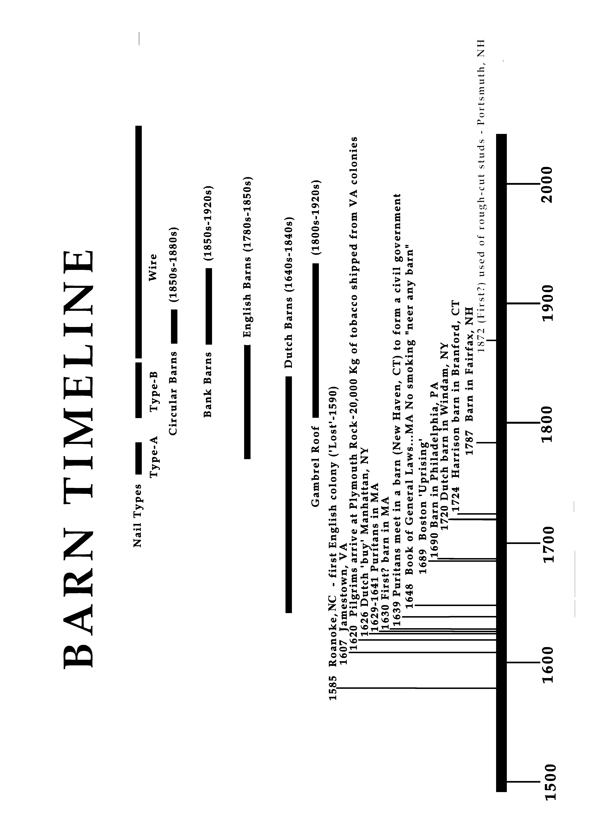

Mark Pilipski BARNS are NOBLE, box 588, Westbrookville, NY 12785 (973)-614-9101

REFERENCES

Barns and Barn Preservation-A Bibliography, Peggy Lee Beedle and Geoffrey M. Gyrisco, Giving Old Barns New Life, Volume 3. University of Wisconsin-Extension
State Historical Society of Wisconsin, Wisconsin Trust for Historic Preservation
http://learningstore.uwex.edu/pdf/G3660-3.pdf

An Age of Barns by Eric Sloane, The American Museum of Natural History, 1967.

Rutgers University, New Brunswick, NJ, Special Collections and University Archives

Trade Catalogs of Nails and Nail Making Machines, Compiled By David Moyer, May 2002, http://www.digitalpresence.com/histarch/nailcats.html

